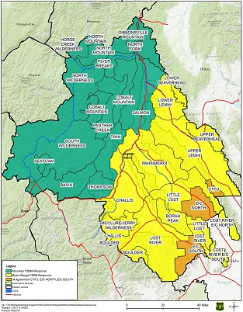

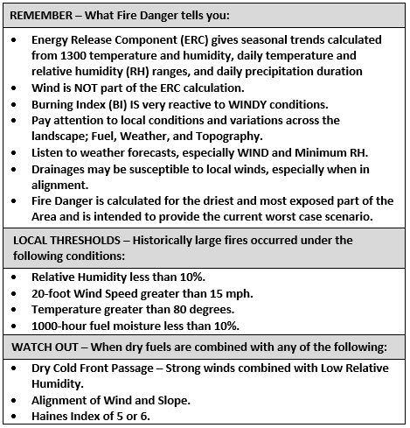

Created on 6/1/2021 by Central Idaho Dispatch